Power BI Assignment - 1
Data Transformation & Data Modeling
Data Import & Transformation:
1. Data Import:
The datasets List of Orders, Order Details, and Sales Target were imported into Power BI using the Get Data option
All datasets were loaded into Power Query Editor for further transformation and preparation.
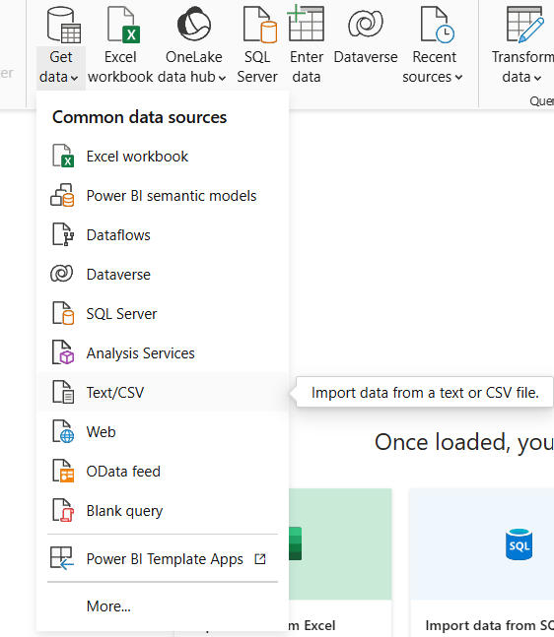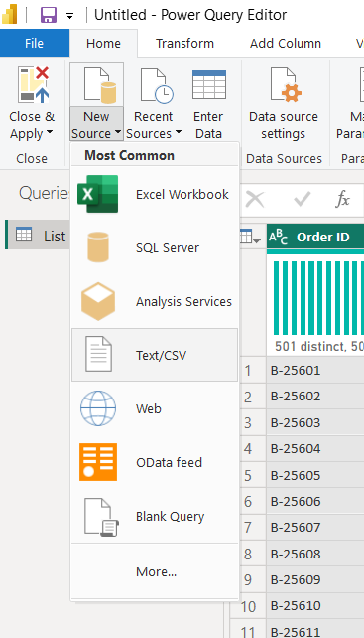
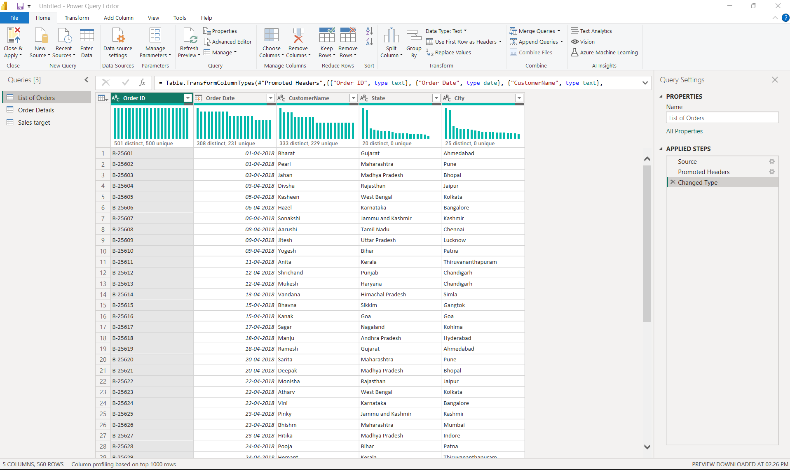
2. Row Limiting & Data Types:
:
The List of Orders table was restricted to the first 500 rows using the Keep Top Rows option in Power Query Editor
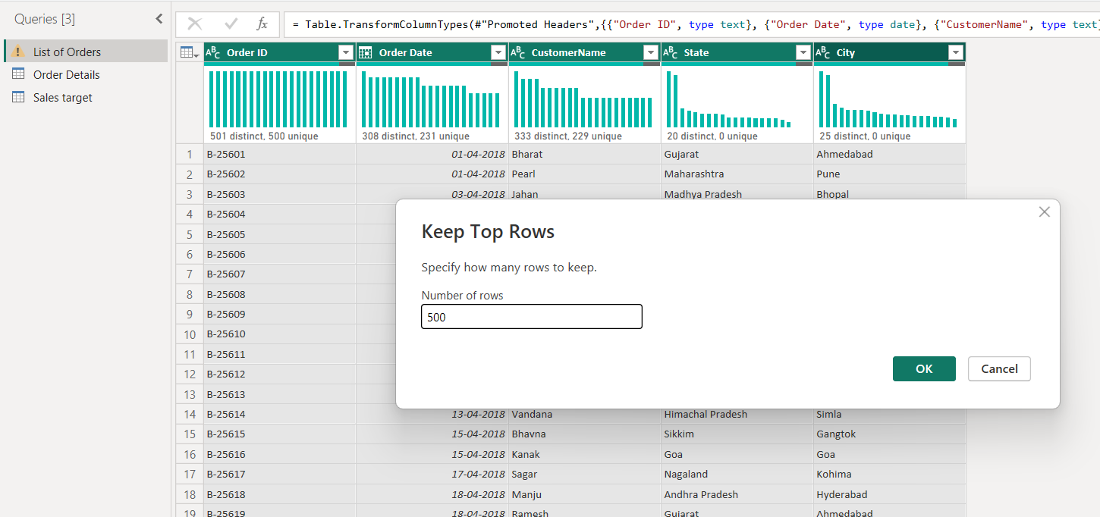

The Order Date column was converted into Date format by using change type option
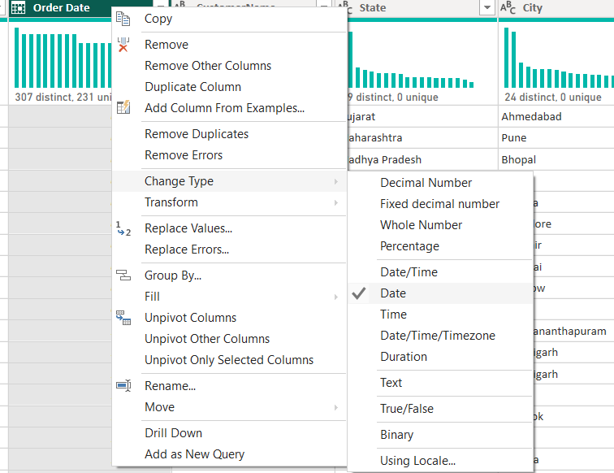

The Amount and Target columns were changed to Fixed Decimal Number format

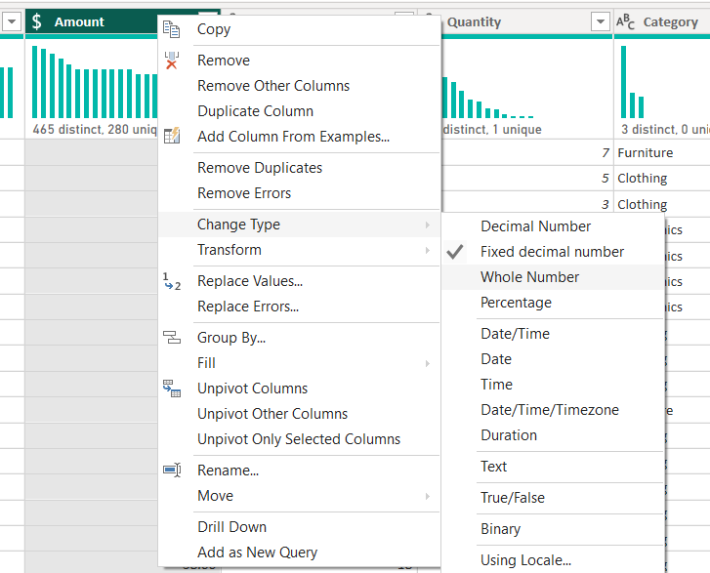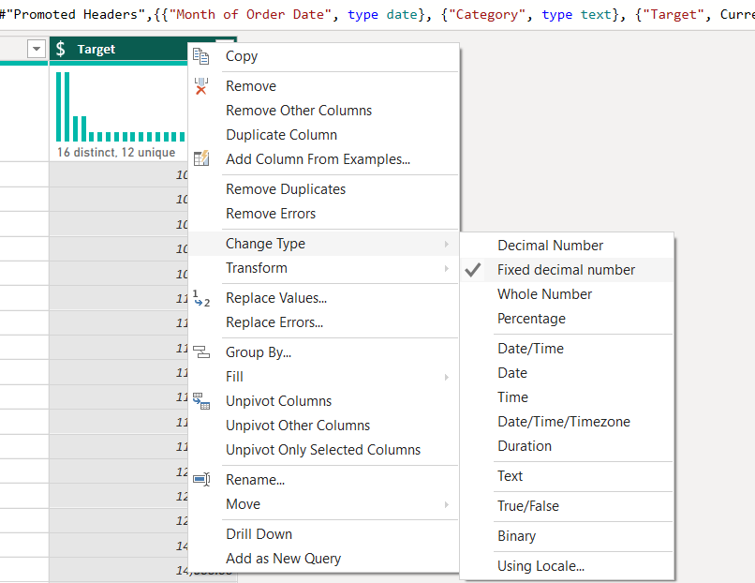

3. Text Formatting:
The CustomerName column was formatted using the Capitalize Each Word option to ensure consistent text formatting and proper capitalization throughout the dataset
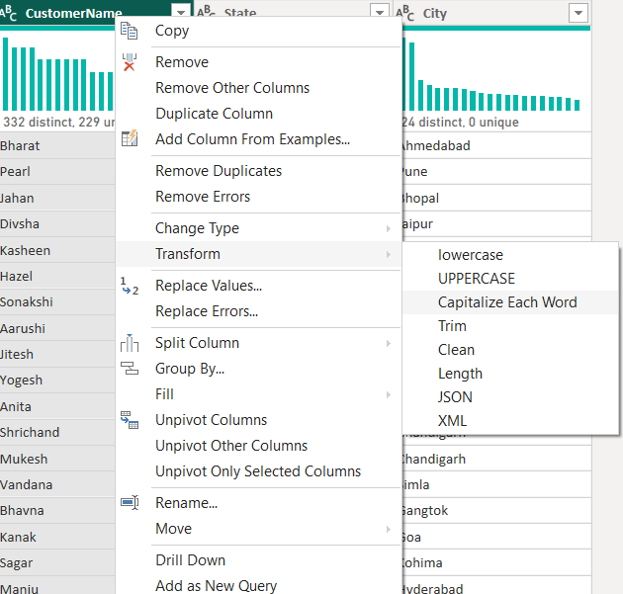
4. Column Creation:
The City and State columns were merged to create a new column named Location in the format “City, State”
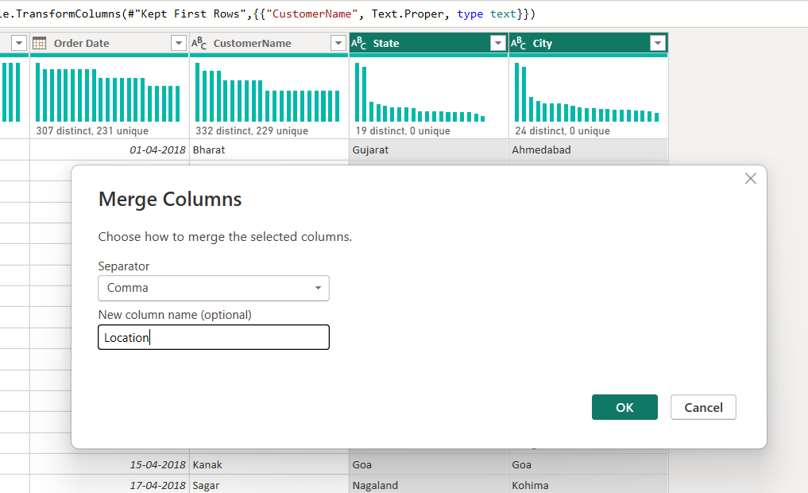

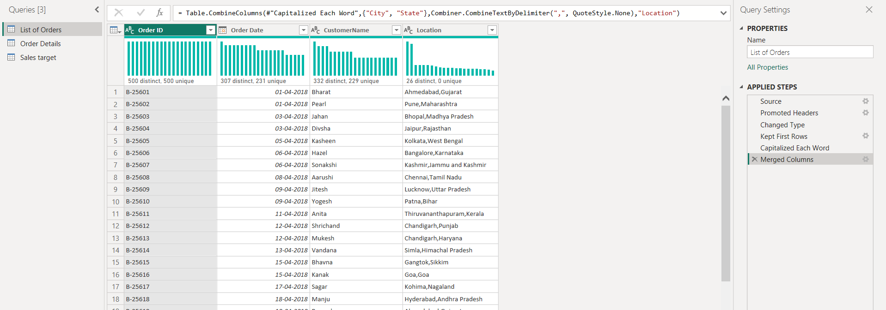
The Profit Margin column was created using a custom formula by dividing Profit by Amount the resulting values were converted into percentage format
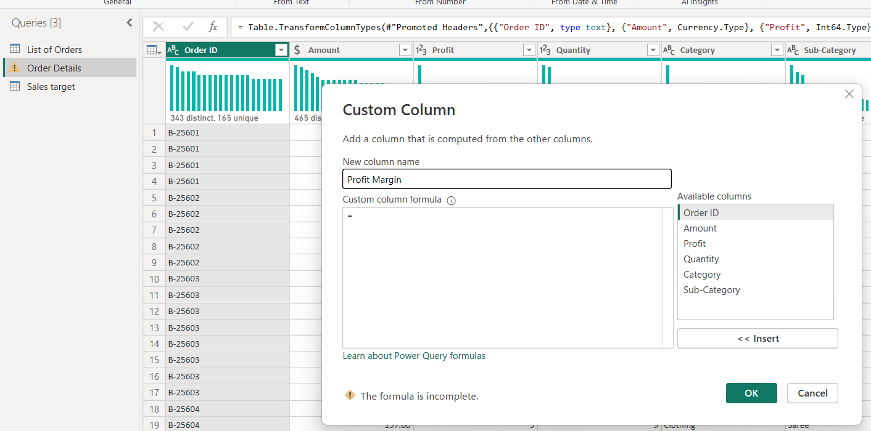
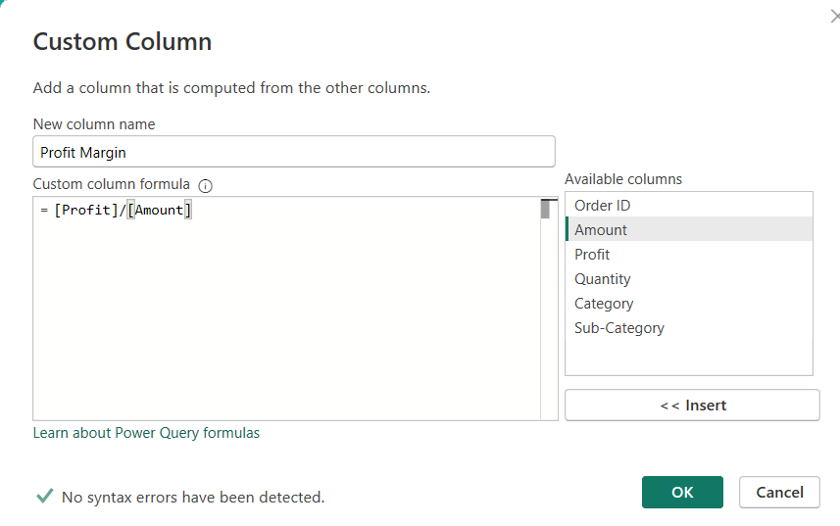
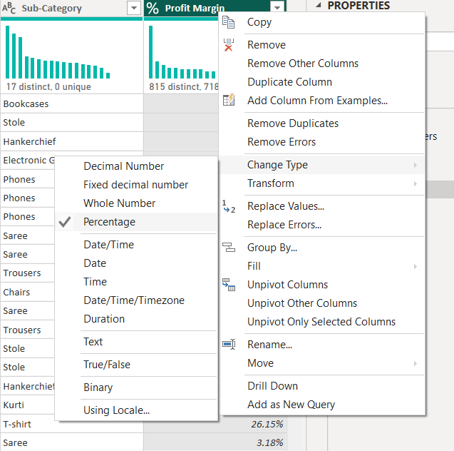
5. Conditional Column:
A conditional column named Profit Status was created to categorize transactions as Profit, Loss, or Break-Even based on the profit values
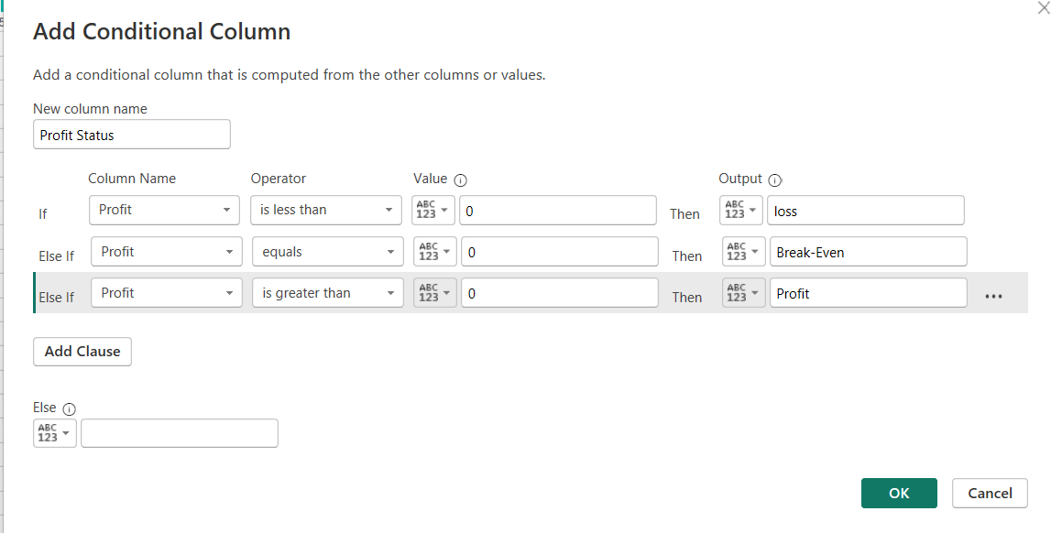
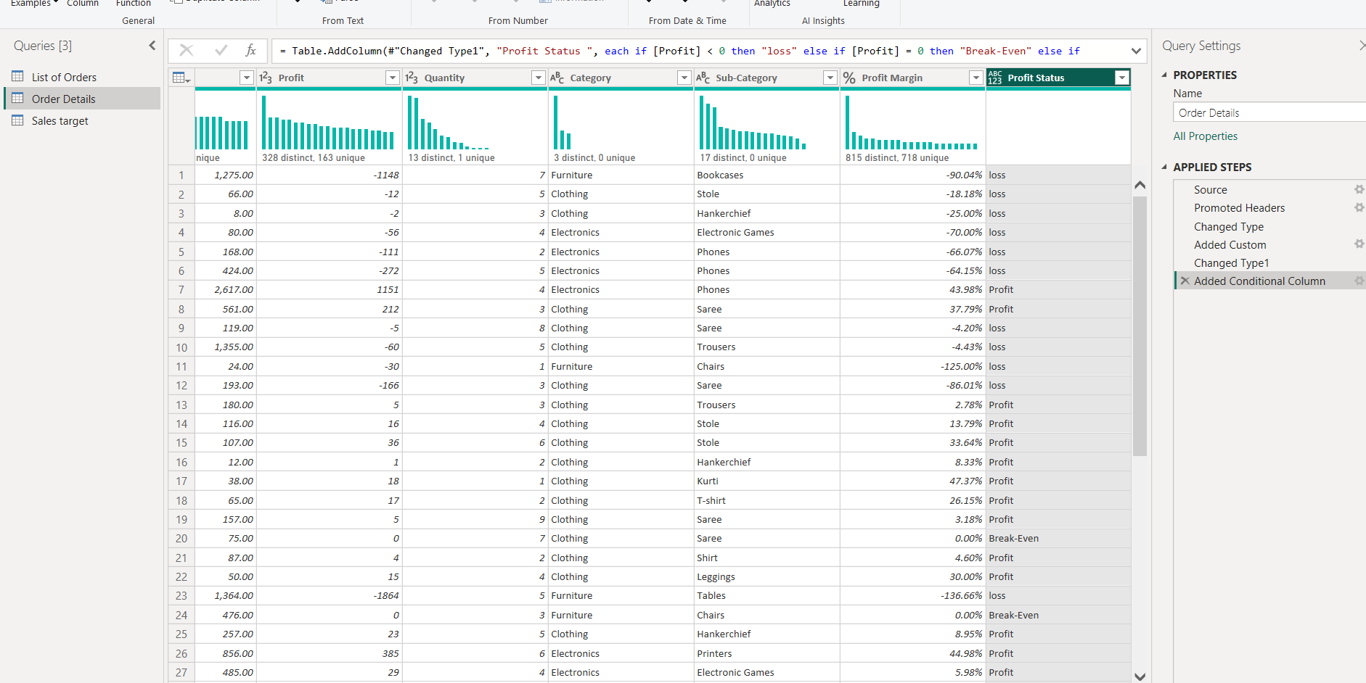
6. Merging Data (Joins):
The List of Orders and Order Details tables were merged using the Order ID column
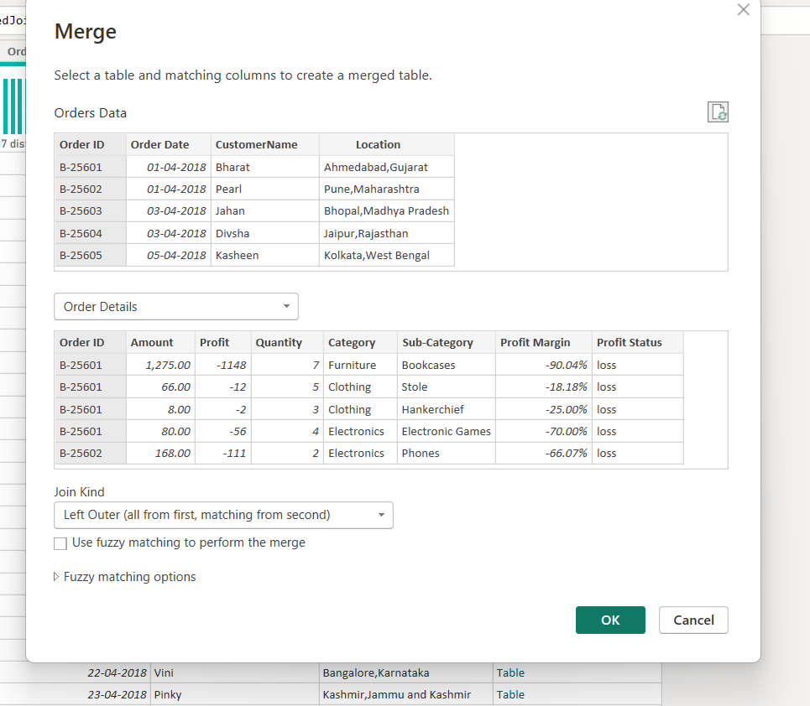

The merged output was renamed as Orders Data to combine order-level and product-level information into a single table for analysis
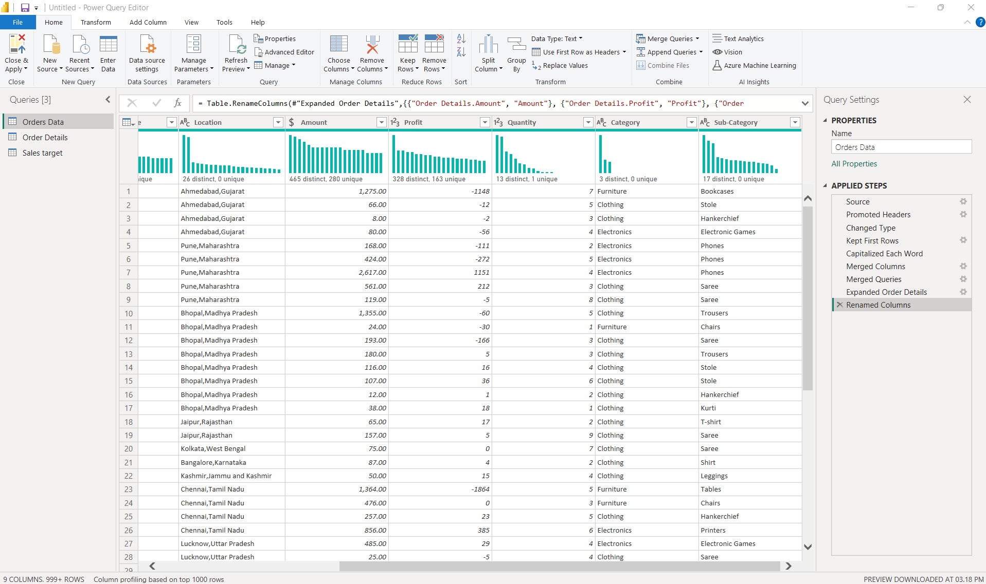
7. Handling Missing Data & Duplicate Data:
All tables were inspected for missing values using column filters in Power Query Editor no null or missing values were identified in the dataset therefore no replacement or removal operations were required
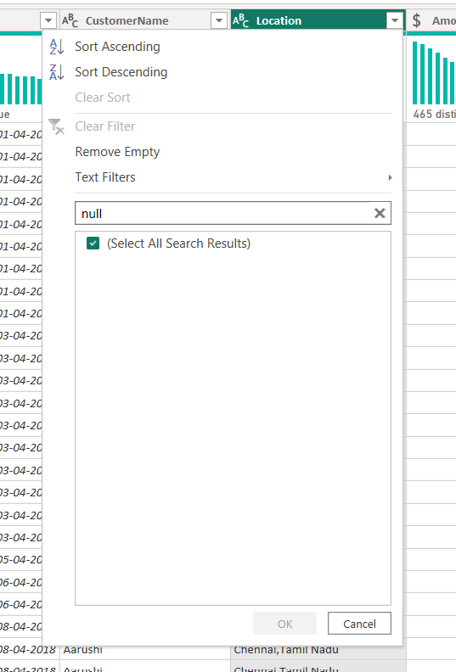
Duplicate rows were checked across all tables using the Keep Duplicates option in Power Query Editor no duplicate records were identified in the dataset; therefore, no duplicate removal operations were required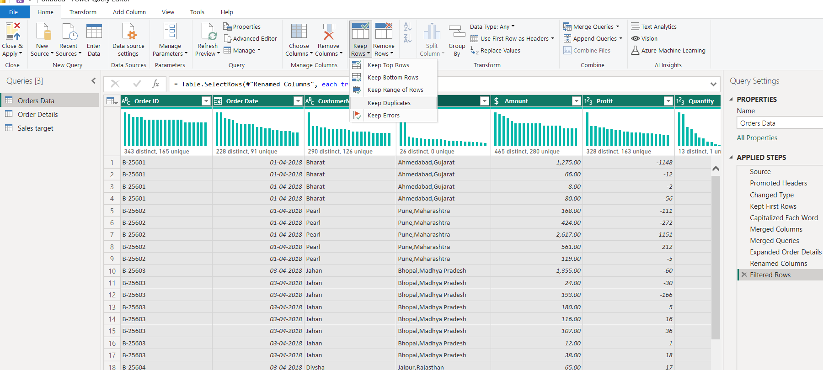
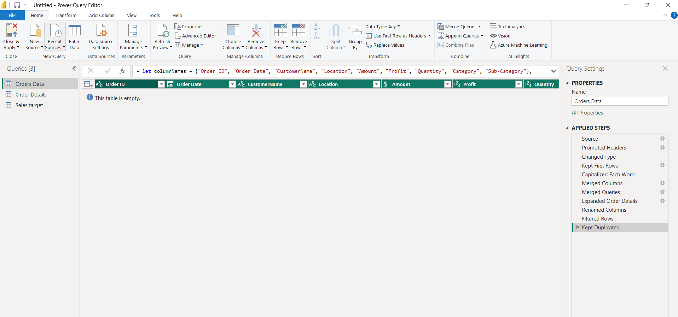
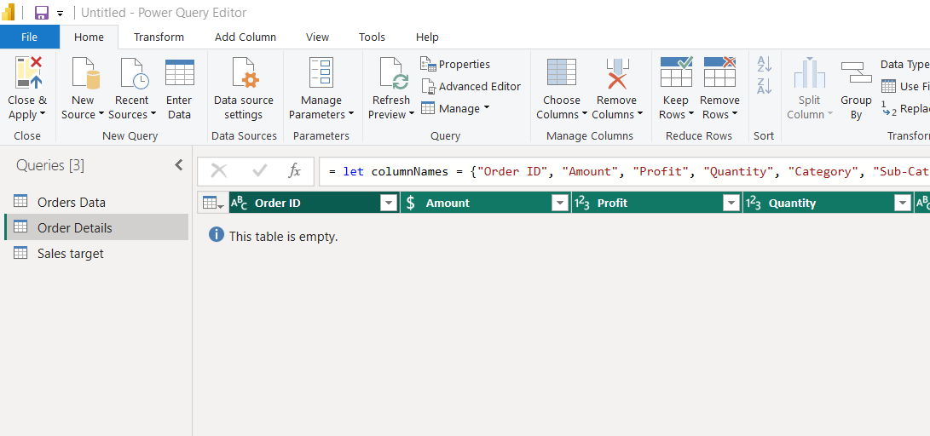
8. Sorting and Filtering Data:
Records in the Orders Data table were sorted by Order Date in descending order using the sorting options in Power Query Editor
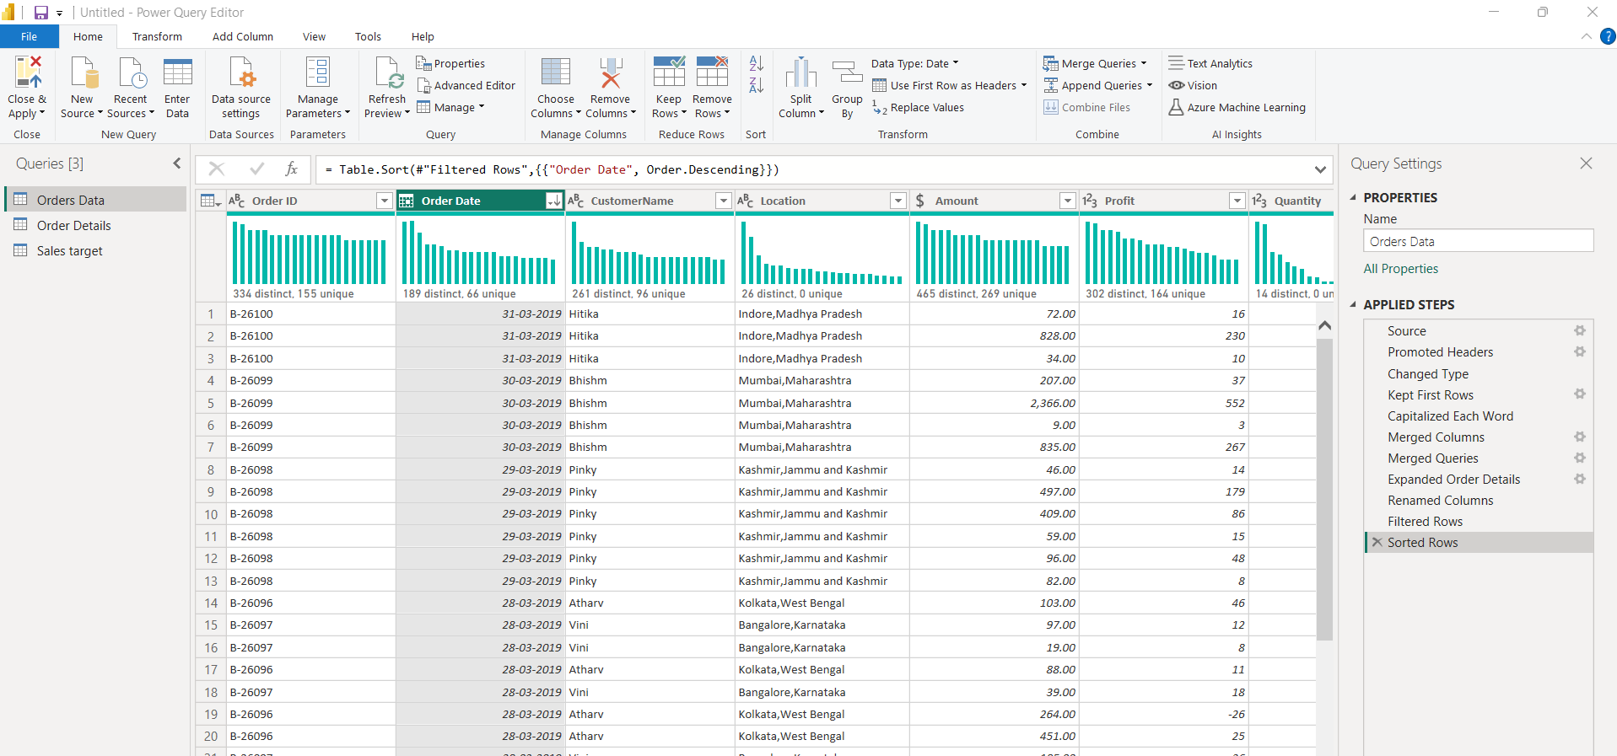
● Apply filters to analyze orders from a specific state (e.g., Tamil Nadu).
ANS: Filters were applied on the Location column to analyze orders specifically from Tamil Nadu
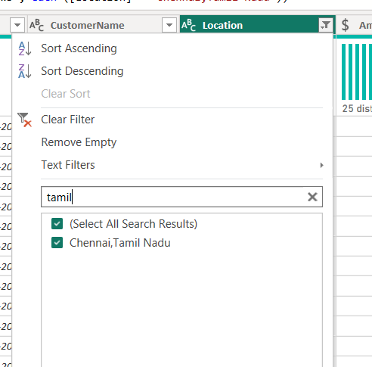
9. Grouping and Aggregating Data:
The Order Details table was duplicated and grouped by Category to calculate the count of Order IDs using the Group By transformation in Power Query Editor
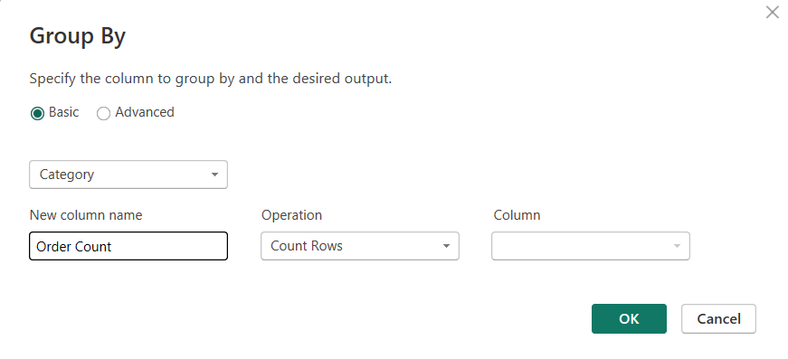
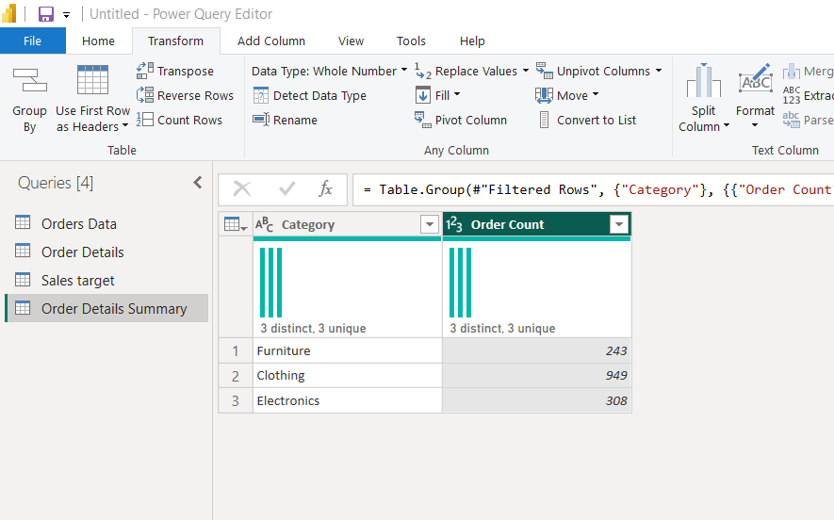

The duplicated Order Details table was grouped by Category to calculate the average profit for each product category

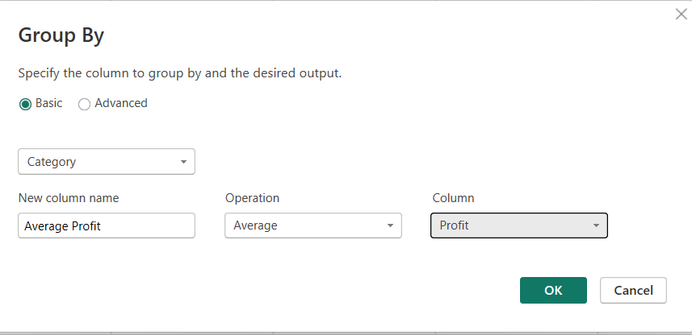
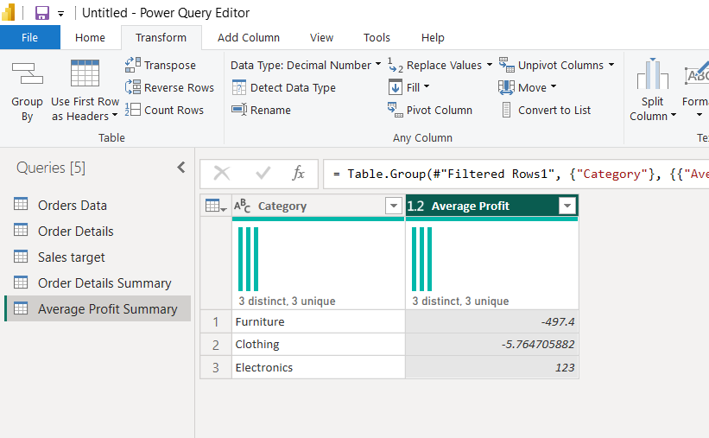

The Order Details table was grouped by Sub-Category to calculate the total sales amount for each sub-category using aggregation functions

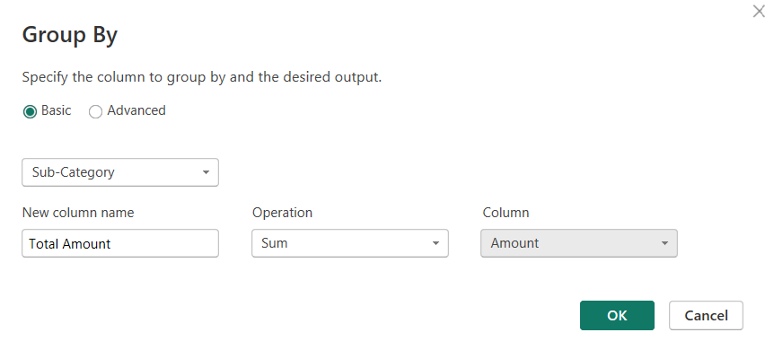
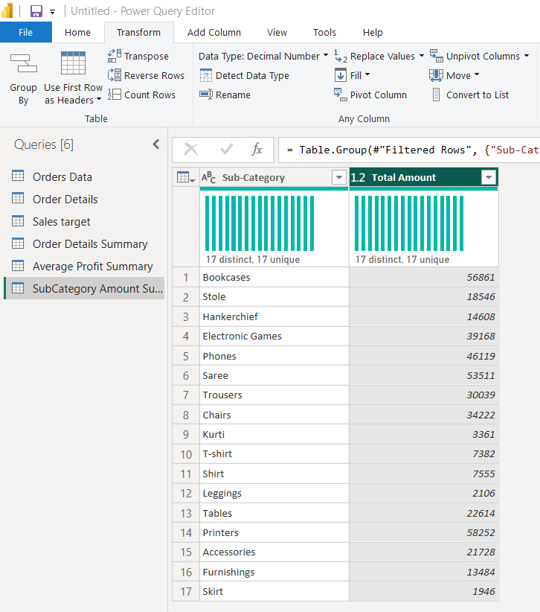

The Sales Target table was duplicated and grouped by Month of Order Date to calculate the total target values for each month

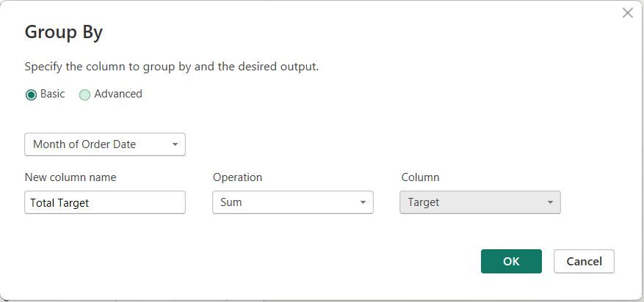
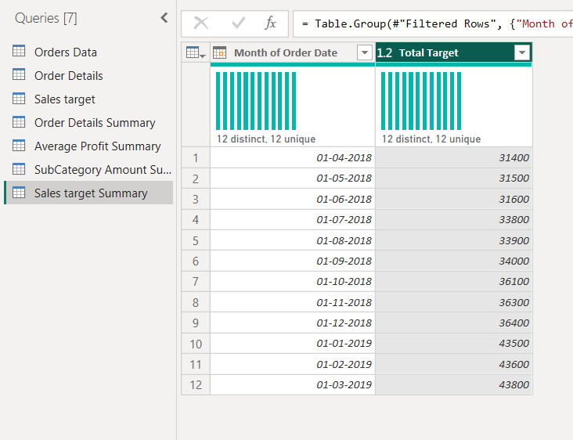

10. Data Modeling:
Relationships were established between the Orders Data and Order Details tables using the Order ID column.
Another relationship was created between the Order Details and Sales Target tables using the Category column.

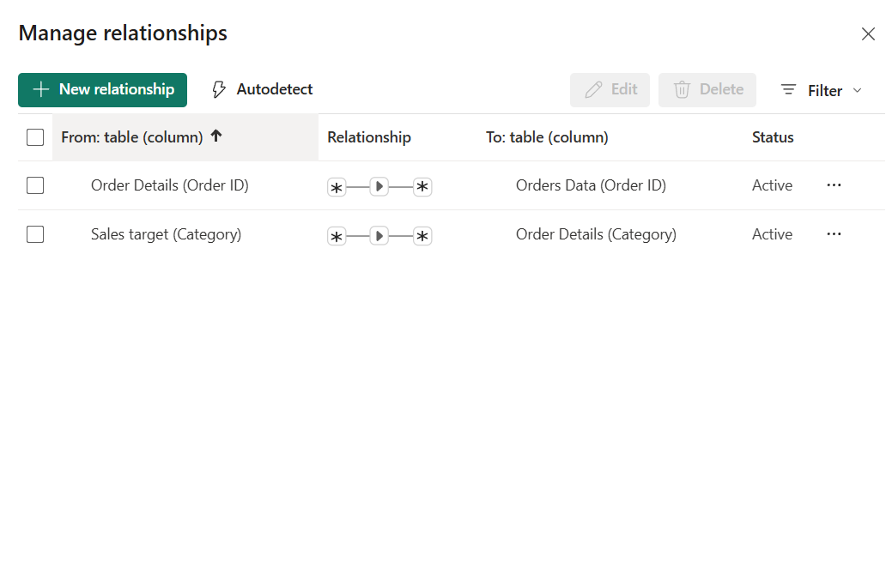
Many-to-many relationships were used because repeated Order ID and Category values were present across related tables as part of the transactional structure of the dataset
